СРО
28-Нұсқа
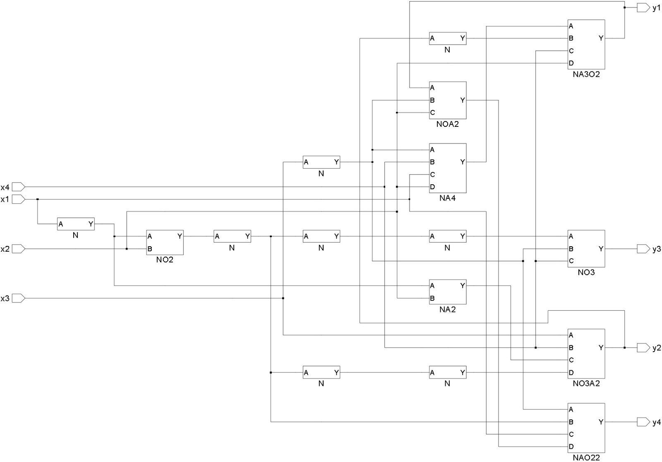

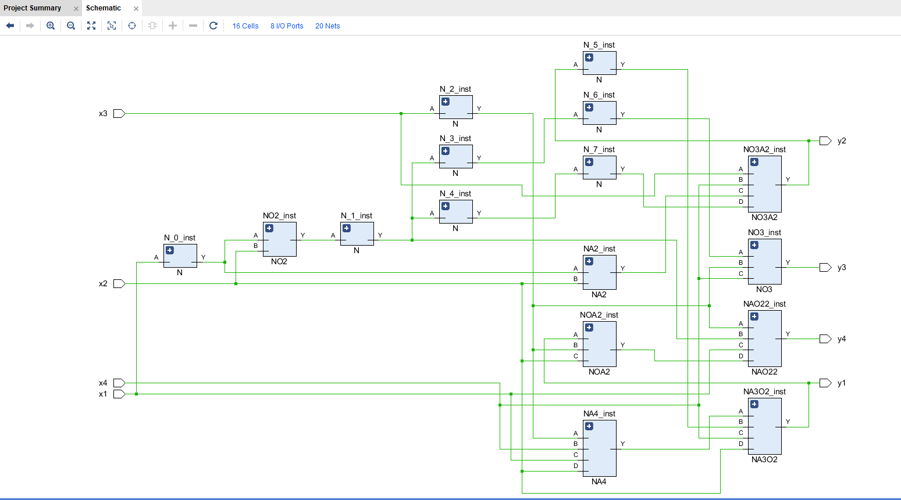
Логикалық функциялар жүйесі:
y1 = NA4 · ȳ2 · (x4 ∨ x2)

y2 = x3 ∨ x4 ∨ ( (x1 · x2)̅ · (x1 ∨ x2)̅ )

y3 = (x1 ∨ x2)̅ ∨ (x3 ∨ x4)̅

y4 = ( (x̅3 · x̅1) ∨ x2 ) ∨ ( x1 · NOA2 )

Ақиқат кестесі:
x1 | x2 | x3 | x4 | y1 | y2 | y3 | y4
0 | 0 | 0 | 0 | 1 | 1 | 0 | 1
0 | 0 | 0 | 1 | 1 | 1 | 0 | 1
0 | 0 | 1 | 0 | 1 | 0 | 1 | 1
0 | 0 | 1 | 1 | 1 | 0 | 0 | 1
0 | 1 | 0 | 0 | 1 | 1 | 0 | 1
0 | 1 | 0 | 1 | 0 | 1 | 0 | 1
0 | 1 | 1 | 0 | 1 | 0 | 1 | 1
0 | 1 | 1 | 1 | 1 | 0 | 0 | 1
1 | 0 | 0 | 0 | 1 | 1 | 0 | 0
1 | 0 | 0 | 1 | 1 | 1 | 0 | 0
1 | 0 | 1 | 0 | 1 | 0 | 1 | 0
1 | 0 | 1 | 1 | 1 | 0 | 0 | 0
1 | 1 | 0 | 0 | 1 | 1 | 0 | 0
1 | 1 | 0 | 1 | 0 | 1 | 0 | 0
1 | 1 | 1 | 0 | 1 | 0 | 1 | 0
1 | 1 | 1 | 1 | 1 | 0 | 0 | 0

